

**SCRUBS** is a student driven initiative that aims to develop supplemental resources for current and future cohorts that will pass through Brody. Members of **SCRUBS** participate in a variety of sub-committees working to create resources for students, by students. These resources aim to offer unique perspectives from students who have walked in the same shoes and can develop resources that we wish we had been exposed to during our time in the course.

The hope is this organization will become a staple of the Brody student body, exemplifying the unique collaborative community that Brody offers. If this is a mission that aligns with your goals and you have the desire to help those that will come behind you, as well as a goal to leave your mark on Brody as a whole, we invite you to join the team!

**Disclaimer:**

The resources that are included in this document are made by students and not the faculty. As such, there is the possibility for errors in our development, although this is mitigated via a team approach to development with multiple stages of vetting. If there is a contradiction with the coursework presented within your course, please go by the course documents. Additionally, **SCRUBS** aims to supply ***supplemental resources***, however these are in no way replacements to the instruction of the Brody faculty. Use these resources as a supplement, but not as your primary source for course material.

Coursepack Practice Questions

**Leg**

*Mack Morgan - BSOM Class of 2026*

**Quiz Level**

1. Which structure separates the posterior compartment of the leg into superficial and deep parts?

A) Interosseous membrane

B) Crural fascia

C) Fascia lata

D) Transverse intermuscular septum

E) Superior extensor retinaculum

2. Which nerve is responsible for innervating muscles of the anterior compartment of the leg?

A) Deep fibular nerve (L4,5 S1,2)

B) Superficial fibular nerve (L4,5 S 1,2)

C) Tibial nerve (L4,5 S1,2,3)

D) Saphenous nerve

E) Sural nerve

3. After visiting his primary care provider for a potential pulled muscle, the doctor informs him that the injury resides in the **deep posterior** compartment. Considering this, which muscle is definitely ***not*** affected?

A) Popliteus

B) Flexor digitorum longus

C) Tibialis posterior

D) Plantaris

E) Flexor hallucis longus

4. A doctor diagnoses her patient with shin splints. Which muscle is the most likely culprit?

A) Tibialis anterior

B) Extensor hallucis longus

C) Extensor digitorum longus

D) Fibularis tertius

E) Fibularis longus

5. Which muscle does not contribute to the borders of the popliteal fossa?

A) Biceps femoris

B) Semimembranosus

C) Semitendinosus

D) Gastrocnemius

E) Soleus

**Test Level**

6. A 36 year old male presents to the ED with right leg pain and loss of some motor function after having his lateral leg, just below the knee, sliced with a piece of machinery. Upon presentation, the patient’s right foot appears to be curved inward (i.e cannot be everted) and mildly plantar-flexed. After performing a physical exam, it is apparent the patient has lost the ability to lift his foot upward and splay his toes. Based upon this clinical presentation, which nerve appears to have been injured?

A) Sural nerve

B) Tibial nerve

C) Common fibular nerve

D) Deep fibular nerve

E) Superficial fibular nerve

7. A 17 year old female presents to the ED after a car accident which inflicted multiple areas of deep trauma to her left leg. After a thorough examination is completed, it is found that the patient is able to invert and evert her foot, and flex her toes, but cannot plantar flex her foot at all. Other than that, all other aspects of the physical exam are normal in terms of nervous and motor function. Given these findings, which structure is most likely to have been severed during her accident?

A) Tibialis anterior

B) Calcaneal tendon

C) Tibialis posterior

D) Flexor hallucis longus

E) Flexor digitorum longus

8. A 30 year old male presents to the ED with almost complete loss of knee flexion while the leg isn’t weight bearing. Sensation is intact across the leg, and all other motor function is completely normal. The resident deduces that a specific muscle has been injured. To pimp the medical student, **he lists a few muscles that could be the cause, and asks you to eliminate the choice that is not possible**.

A) Soleus

B) Plantaris

C) Gastrocnemius (medial head)

D) Gastrocnemius (lateral head)

E) Popliteus

9. While attempting to remove a thrombus lodged in a patient’s femoral artery, the vascular surgeon decides his best option is to advance a wire up the vasculature, starting via access through the lateral plantar artery. Which of the following pathways provides the most direct path to the location of the thrombus?

A) Lateral plantar artery → posterior tibial artery → popliteal artery → femoral artery

B) Lateral plantar artery → fibular artery → popliteal artery → femoral artery

C) Lateral plantar artery → anterior tibial artery → popliteal artery → femoral artery

D) Lateral plantar artery → posterior tibial artery → fibular artery → femoral artery

E) Lateral plantar artery → anterior tibial artery → common tibial artery → femoral artery

10. It is determined that a 27 year old female patient has a vascular occlusion somewhere in her right leg. Upon palpation, it is noted that her right popliteal pulse is absent. After performing imaging, it is noted that the vascular supply to her femoral head is intact. Given this information, where is the occlusion most likely located?

A) Compression of the femoral artery under the inguinal ligament

B) Stricture of the anterior tibial artery through the interosseous membrane

C) Stricture of the posterior tibial artery through the interosseous membrane

D) Stricture of the femoral artery at the adductor hiatus

E) Compression of the profunda femoris distal to the circumflex branches

**Answers**

**1. The correct answer is** D) Transverse intermuscular septum

A) Interosseous membrane: This structure unites the tibia with the fibula

B) Crural fascia: This is the deep fascia of the leg, which divides it into its anterior, lateral, and posterior parts

C) Fascia lata: This is located on the posterior portion of the knee, continuous anteriorly with the crural fascia

D) Transverse intermuscular septum: This is correct, it is a component of crural fascia that divide the leg into anterior, posterior, and lateral compartments (each with an associated nerve)

E) Superior extensor retinaculum: This is a thickening of transverse fibers of the crural fascia on the anterior surface of the ankle, in place to prevent bowstringing of the many tendons passing to the foot

**2. The correct answer is** A) Deep fibular nerve (L4,5 S1,2)

A) Deep fibular nerve (L4,5 S1,2): This is correct.

B) Superficial fibular nerve (L4,5 S 1,2): This nerve innervates muscles of the lateral compartment.

C) Tibial nerve (L4,5 S1,2,3): This nerve innervates muscles of the posterior thigh and leg compartment.

D) Saphenous nerve: This nerve is a terminal branch of the femoral nerve which supplies the cutaneous portion of the medial knee down the anteromedial leg.

E) Sural nerve: This cutaneous nerve supplies the skin of the posterolateral leg and lateral foot, and is created by the joining of the communicating branch of the lateral sural nerve and the medial sural cutaneous nerve.

**3. The correct answer is** D) Plantaris

All of the other answer choices are a part of the deep portion of the posterior compartment of the leg. However, plantaris, along with the soleus and gastrocnemius, make up the superficial posterior compartment.

**4. The correct answer is** A) Tibialis anterior

Shin splints are caused by overexertion of anterior leg muscles. All answer choices are within the anterior compartment, except the fibularis longus (lateral compartment). However, the most typical muscle to tear and cause this injury is the tibialis anterior.

**5. The correct answer is** E) Soleus

A) Biceps femoris: Makes up the superolateral border

B) Semimembranosus: Makes up the superomedial border

C) Semitendinosus: Makes up the superomedial border

D) Gastrocnemius: Makes up the inferior border

E) Soleus: The soleus has a horseshoe-shaped origin from the tibia and fibula and does not act on the knee joint; it is positioned inferior to the inferior border of the popliteal fossa.

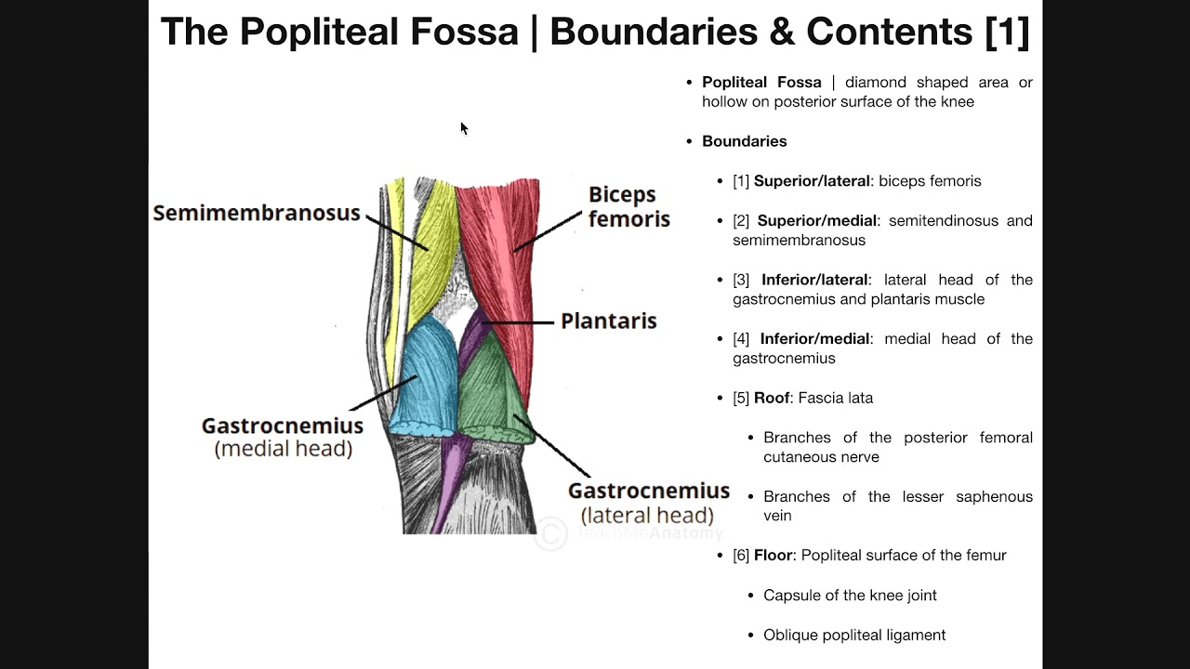

**6. The Correct answer is** C) Common fibular nerve

The patient is displaying the classic signs of “foot drop,” which can occur after trauma that severs the common fibular nerve. This nerve is common to injure as it passes superficially just beneath the fibular head, so superficial trauma can have this effect. This superficial passage occurs before the nerve splits into superficial and deep portions, so either of those choices are much less likely to be individually affected following superficial trauma. The “foot drop” occurs because the common fibular nerve (which splits into **superficial** and **deep**) ends up supplying the **lateral** and **anterior** leg compartments respectively, thus its severance would cause the loss of the ability for eversion of the foot, as well as dorsiflexion. When function is lost, the opposing muscle groups appear to “take over” as they are unopposed, which is why foot drop appears as an inward-turned, plantar-flexed foot.

**7. The correct answer is** B) Calcaneal tendon

The key to this question is that the only finding of note is the inability to plantar flex. Even more important, the patient is able to flex her toes. Thus, any structure that assists in functions outside of plantar flexion should be excluded.

A) Tibialis anterior: This muscle aids dorsiflexion and eversion at the ankle.

B) Calcaneal tendon: This is correct.

C) Tibialis posterior: This muscle aids in plantar flexion and inversion.

D) Flexor hallucis longus: This muscle flexes the big toe and plantar flexes.

E) Flexor digitorum longus: This muscle also flexes the toes and plantar flexes.

**8. The correct answer is** A) Soleus

A) Soleus: This is correct, because this muscle originates from the tibia and fibula, and thus has no action involving the knee.

B) Plantaris: This acts as a weak knee flexor and plantar flexor of the ankle.

C) Gastrocnemius (medial head): This muscle flexes the knee while the leg is not weight bearing.

D) Gastrocnemius (lateral head) This muscle flexes the knee while the leg is not weight bearing.

E) Popliteus: This muscle is a weak flexor of the knee and “unlocks” the knee prior to flexion.

**9. The correct answer is** A) Lateral plantar artery → posterior tibial artery → popliteal artery → femoral artery

The femoral artery continues toward the popliteal fossa, and becomes the popliteal artery as it enters. From there, the popliteal splits off into anterior and posterior tibial. The posterior tibial continues and divides into medial and lateral plantar arteries. The posterior tibial artery does also give off a fibular artery, but that artery does not contribute to the lateral plantar artery. Thus, to reverse this route and reach the thrombus, the correct sequence is “lateral plantar → posterior tibial → popliteal → femoral”

**10. The correct answer is** D) Stricture of the femoral artery at the adductor hiatus

The patient has an absent popliteal pulse. This pulse is taken in the popliteal fossa using the popliteal artery. Since this is absent, the occlusion must be upstream to this location. So, the anterior tibial answer choices are incorrect. Additionally, blood supply to the femoral head is intact. Blood supply to the femoral head comes from the medial and lateral circumflex femoral branches (*primarily the medial circumflex*) off of the profunda femoris artery. Thus, the inguinal ligament compression of the femoral artery (which happens prior to the branching off of the profunda femoris) must be incorrect for the femoral head vascular supply to remain intact. This also excludes compression of the profunda femoris distal to the circumflex branches, because although the femoral head vasculature would remain intact, you would be able to palpate a normal popliteal pulse. This leaves stricture at the adductor hiatus of the femoral artery as the only correct answer choice. The femoral artery travels through the adductor hiatus to become the popliteal artery, so if it encountered stricture here, the popliteal pulse would be absent, but the stricture would be past the branching point of the profunda femoris (and therefore the medial and lateral circumflex branches of such) meaning the vasculature to the femoral head would remain intact.