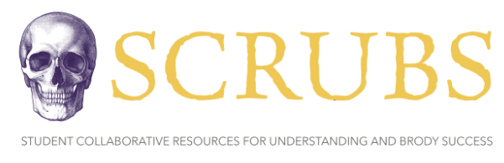

**SCRUBS** is a student driven initiative that aims to develop supplemental resources for current and future cohorts that will pass through Brody. Members of **SCRUBS** participate in a variety of sub-committees working to create resources for students, by students. These resources aim to offer unique perspectives from students who have walked in the same shoes and can develop resources that we wish we had been exposed to during our time in the course.

The hope is this organization will become a staple of the Brody student body, exemplifying the unique collaborative community that Brody offers. If this is a mission that aligns with your goals and you have the desire to help those that will come behind you, as well as a goal to leave your mark on Brody as a whole, we invite you to join the team!

**Disclaimer:**

The resources that are included in this document are made by students and not the faculty. As such, there is the possibility for errors in our development, although this is mitigated via a team approach to development with multiple stages of vetting. If there is a contradiction with the coursework presented within your course, please go by the course documents. Additionally, **SCRUBS** aims to supply ***supplemental resources***, however these are in no way replacements to the instruction of the Brody faculty. Use these resources as a supplement, but not as your primary source for course material.

Coursepack Practice Questions

**HEAD AND NECK VASCULATURE**

*Carly Fassler - Co 2025*

**Quiz Level**

1. The subclavian artery arises from the ____________ on the right but arises from the _____ on the left.

A) Cephalic trunk, aorta

B) Brachiocephalic trunk, aorta

C) Aorta, thyrocervical trunk

D) Transverse cervical artery, aorta

E) Internal carotid artery, common carotid artery

2. Which of the following vascular structures passes between the anterior and middle scalene muscles?

A) Superior thyroid artery

B) Inferior thyroid artery

C) Subclavian artery

D) Transverse cervical artery

E) Superior intercostal artery

3. The carotid body is located at the:

A) Origin of the external carotid artery

B) Origin of the internal carotid artery

C) Bifurcation of the common carotid artery

D) Bifurcation of the vagus nerve

E) Bifurcation of the brachiocephalic artery

4. The carotid sinus is located at the:

A) Origin of the internal carotid artery

B) Bifurcation of the vagus nerve

C) Bifurcation of the brachiocephalic artery

D) Bifurcation of the common carotid artery

E) Origin of the external carotid artery

5. The internal jugular vein empties into the

A) External jugular vein

B) Sigmoid sinus

C) Brachiocephalic vein

D) Anterior jugular vein

E) Superior vena cava

**Test Level**

6. A 67 year old female is undergoing a deep neck dissection for a large squamous cell carcinoma of the neck when the surgeon notices profuse bleeding from the deep cervical artery. Which of the following arteries should be ligated to stop the bleeding?

A) Inferior thyroid artery

B) Costocervical trunk

C) Thyrocervical trunk

D) Transverse cervical artery

E) Ascending cervical artery

7. During your vascular surgery rotation, you are observing a carotid endarterectomy for a 77 year old female who suffered a stroke, the carotid sinus is damaged. You remember that this injured structure:

A) Is located at the origin of the external carotid artery

B) Is innervated by the facial nerve

C) Functions as a chemoreceptor

D) Is stimulated by changes in blood pressure

E) Communicates freely with the cavernous sinus

8. An 18 year old male presents to the emergency department experiencing shortness of breath, wheezing, and swelling of the lips and tongue after ingesting a peanut butter cookie at a birthday party. Circulatory collapse is impending and an emergency airway is required. A low tracheostomy is performed below the isthmus of the thyroid, which of the following vessels may be encountered?

A) Inferior thyroid artery

B) Inferior thyroid vein

C) Costocervical trunk

D) Superior thyroid artery

E) Right brachiocephalic vein

9. A 43-year old male presents to the emergency department following a bar fight in which he was struck in the head with a blunt object. His pupils are sluggish and he only withdraws to pain. Following acute stabilization and intubation, he undergoes a CT scan of the head which demonstrates a large epidural hematoma. He has most likely injured what vessel?

A) Vertebral artery

B) Internal carotid artery

C) External jugular vein

D) Middle meningeal artery

E) Posterior inferior cerebellar artery (PICA)

10. A 32-year old female returns from a hiking trip 2 weeks after she suffered a small laceration to her scalp on a sharp branch while swimming in a stream. She did not have access to sterile water or first aid during her trip. She develops fevers to 103F, vomiting, and altered mental status and is brought to the hospital. CT scan localizes a deep brain infection. The infection most likely traveled along what anatomical route?

A) Internal carotid vein

B) External carotid artery

C) Middle meningeal artery

D) Brachiocephalic vein

E) Parietal emissary veins

**Answers**

**1.** The correct answer is **B) brachiocephalic trunk, aorta.**

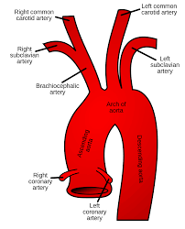

**2.** The correct answer is **C) subclavian artery.**

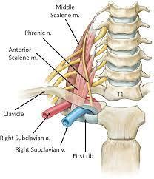

**3.** The correct answer is **C) bifurcation of the common carotid artery.**

**4.** The correct answer is **A) origin of the internal carotid artery.**

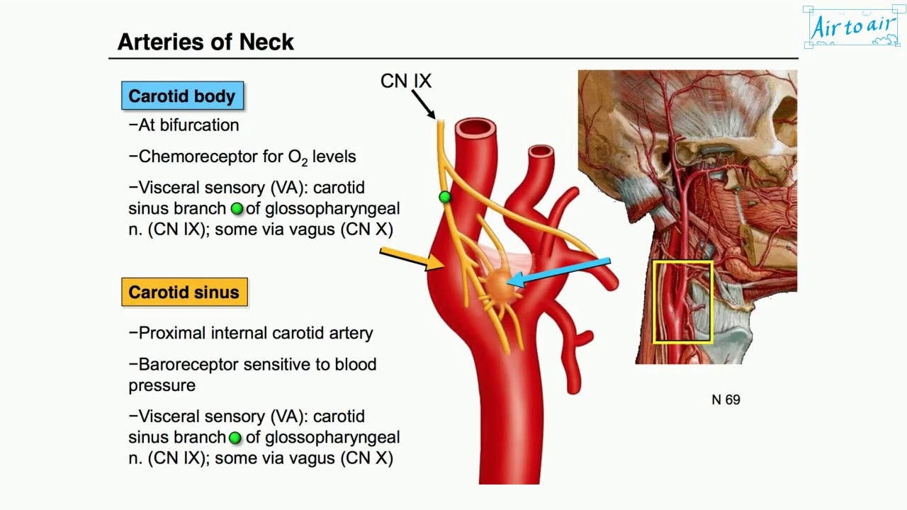

**5.** The correct answer is **C) brachiocephalic vein.**

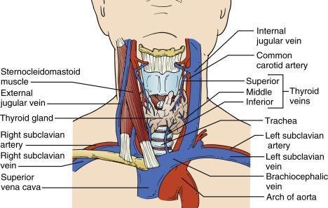

**6.** The correct answer is **B) costocervical trunk** because it divides into the deep cervical and superior intercostal arteries. The thyrocervical trunk gives off the suprascapular, transverse cervical, and inferior thyroid artery. The ascending cervical artery is a branch of the inferior thyroid artery.

**7.** The correct answer is **D)** the carotid sinus, a spindle-shaped dilatation located at the origin of the internal carotid artery, **is a pressoreceptor that is stimulated by changes in blood pressure.** The carotid sinus is at the origin of the internal carotid artery and is innervated by the carotid sinus branch of the glossopharyngeal nerve and nerve to the carotid body of the vagus nerve. It is not a venous sinus and thus does not communicate with the cavernous sinus. The carotid body functions as a chemoreceptor.

**8.** The correct answer is **B)** a low tracheotomy is a surgical incision of the trachea through the neck and below the isthmus of the thyroid gland. **The inferior thyroid veins** drain the thyroid gland, descend in front of the trachea, and enter the brachiocephalic veins. Consequently, these veins are closely associated with the isthmus of the thyroid gland. Other blood vessels are not closely related with the front of the trachea and the isthmus of the thyroid gland.

**9. The correct answer is D) the middle meningeal artery.** Blunt trauma to the skull overlying the **pterion** is the most commonly implicated injury resulting in an epidural hematoma due to the close anatomic association with the middle meningeal artery. The other mentioned vessels are not associated with epidural hematomas.

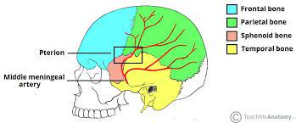

**10. The correct answer is E) the parietal emissary veins.** Valveless emissary veins pass through the skull and connect to external veins (i.e the scalp) and provide an anatomical route by which infection may pass from the skin surface deep into the brain. Infection does not tend to enter via arterial blood supply given rich vascularization.

*Questions #6-8 adapted from BRS Anatomy.*